Project 1: Image Edge Detection
Edge detection: an “edge” is a place where image intensity changes abruptly. Edges can indicate the borders of objects.
1.1 Filters
The intensity changes associated with horizontal edges can be detected by ﬁlter:
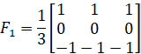
The intensity changes associated with vertical edges can be detected by ﬁlter:
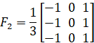

Conduct edge detection on the two given images “license plate” and “lena” in vertical and horizontal direction separately. This can be achieved by conducting convolution operation of the given images and filters. Include your code and result images in your report.

1.2 Sobel edge detector
The process of using Sobel operator for edge detection is as follows.
(1) Calculate gradient images in vertical and horizontal. Speciﬁcally, assume the original image is I. Use two 3 ∗ 3 kernels to convolve with I to calculate approximations of the derivatives (one for horizontal changes, and one for vertical).
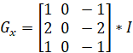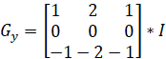
(2) Calculate the gradient magnitude.
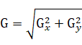
(3) Binarisation (decide edge points): set a threshold (varies from [0 255]; or use methods to set threshold, e.g. histogram); the points with a magnitude larger than the threshold are edge points.

Based on this process to realize edge detection on image “license plate” and “lena”. Include your code and result images in your report.

1.3 Edge detection using library functions
The Matlab or Python library contains edge detection functions, e.g. “edge()” in Matlab. These library functions can realize edge detection with operators, e.g. ‘Sobel’, ‘Prewitt’, ‘Roberts’, ‘Canny’ and so on. Try these operators in Matlab or Python on image “lena”, include the result images in your report.

- Optional assignment: You are encouraged to present your work. You can make a ppt file or just use your report to show your work.

